Week 4 – Take Home Assignment

- Finding the maximum sub array sum of a given number array (using left half and
right half divide and conquer approach)

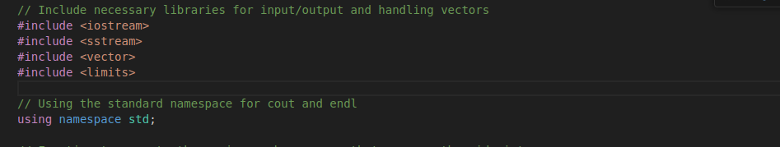
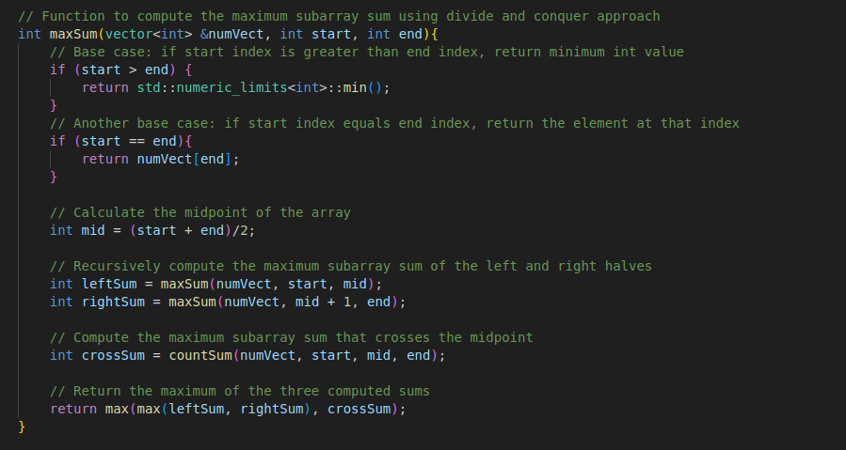
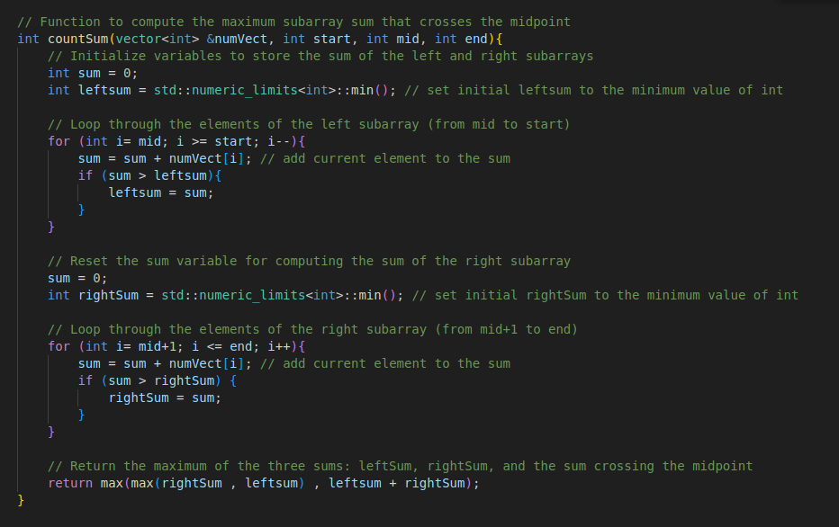
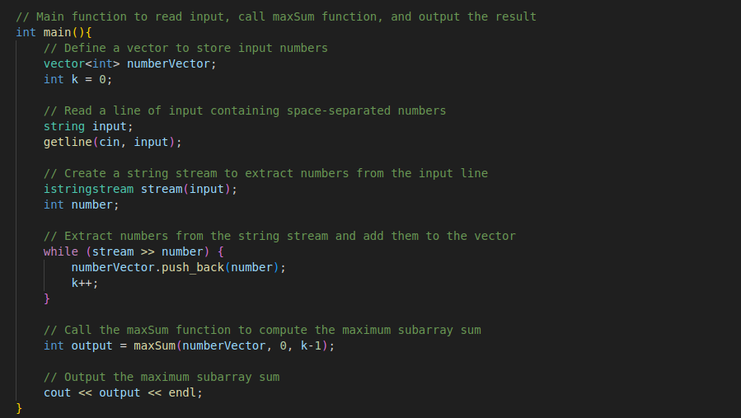
- Recurrence relation ==> T(n) = 2 T (n / 2) + n
